Project Proposal: Web-Based Automated Penetration Testing Platform

1. Introduction

1.1 Introduction
As cyber threats continue to rise globally, organisations increasingly require systematic, efficient, and accurate penetration testing to identify vulnerabilities within their digital infrastructures. Traditional penetration testing is often expensive, labour-intensive, and inconsistent due to variations in human expertise (Scarfone & Mell, 2008).
To address this, the proposed project aims to develop a Web-Based Automated Penetration Testing Platform. This platform will integrate user authentication (signup/login), a secure dashboard, and built-in automated pentesting modules including reconnaissance, port scanning, vulnerability scanning, and reporting. The solution ensures convenience, accessibility, and standardised testing results (Kubernetes & Williams, 2020).

1.2 Current Scenario in Nepal
In Nepal, digital adoption has grown rapidly—banks, e-commerce platforms, government portals, and educational systems increasingly depend on web services. Despite this growth, cybersecurity readiness remains low due to limited expertise, inadequate investment in security audits, and lack of automated testing tools (Basnet, 2021). Reports from the Nepal Telecommunications Authority show a rise in cyber incidents caused by weak authentication systems, misconfigured servers, and unpatched applications (NTA, 2023).
A web-based automated testing platform can provide an accessible and cost-effective security solution for Nepali organisations struggling to perform regular manual penetration tests.

1.3 Project as a Solution
The proposed solution is a web application that provides:
- User Registration and Login System using secure hashing.
- Dashboard with automated penetration testing tools.
- Scanning Modules such as:
  - Subdomain Enumeration
  - Reconnaissance
  - Port & Service Scanning
  - Web Vulnerability Scanning (XSS, SQLi, LFI, etc.)
- Automated Reporting (PDF/HTML)
- Web-based GUI accessible from any device.
This platform aligns with global industry standards such as NIST and OWASP, enabling consistent security testing at low cost (OWASP, 2021).

2. Expected Outcomes and Deliverables

2.1 Expected Outcomes
- Fully functional web-based pentesting platform.
- Secure login and role-based access.
- Integrated scanning tools accessible via dashboard.
- Automated reports with risk severity classifications.
- Improved cybersecurity awareness and practice among Nepali organisations.

2.2 Deliverables
- Complete Web Application (Frontend + Backend).
- User registration/login system.
- Dashboard with automated scanning tools.
- Reporting engine.
- User manual and documentation.
- Final research report.
- Gantt chart, milestones, and demonstration video.

3. Project Risks and Contingency Plans
Risk | Impact | Mitigation
Web misuse for illegal hacking | High | Enforce login, disclaimers, logs, and consent verification (ENISA, 2019)
High server workload → slow scans | Medium | Implement background tasks / asynchronous execution
Vulnerability scanner false positives | Medium | Validate with multiple detection methods
Authentication attacks | Medium | Use hashing, rate-limiting, CAPTCHA
Data leakage | High | Use HTTPS, encryption, logs monitoring

4. Methodology

4.1 Selected Methodology
An Agile (SCRUM) Methodology is selected because it supports iterative development, scalability, and rapid feedback cycles, especially for security-related projects (Schwaber & Sutherland, 2020).

4.1.1 Agile Methodology (SCRUM Framework)
- Product Backlog: login system, dashboard, modules, reporting
- Sprint Planning: 1–2 week sprints
- Daily Standups: progress updates
- Sprint Review: test new module
- Sprint Retrospective: improvements for next sprint
Agile improves adaptability and ensures the security modules evolve consistently (Pressman, 2019).

5. Resource Requirements

5.1 Hardware
- A laptop/PC with minimum 8GB RAM
- Server or local machine for hosting
- External drives for logs

5.2 Software
- Python (Flask/Django) or Node.js for backend
- HTML, CSS, JavaScript for frontend
- Kali Linux tools integration
- Database (MySQL/PostgreSQL)
- Python libraries (requests, nmap, beautifulsoup4)
- Virtual machines (DVWA, bWAPP, Metasploitable)

6. Work Breakdown Structure (WBS)
Phase | Tasks
Planning | Requirements, literature review
Design | UI/UX, database schema, architecture
Development | Signup/login, dashboard, tools integration
Testing | Unit tests, vulnerability detection accuracy
Deployment | Host web app, secure configuration
Documentation | Manual + final report

7. Milestones
- Requirement finalisation – Week 1
- UI/UX + system design – Week 2
- Signup/Login module – Week 3
- Dashboard development – Week 4
- Recon & Subdomain tools – Week 5
- Port scanner – Week 6
- Web vulnerability scanner – Week 7
- Automated reporting – Week 8
- System testing – Week 9
- Final submission – Week 10

8. Gantt Chart
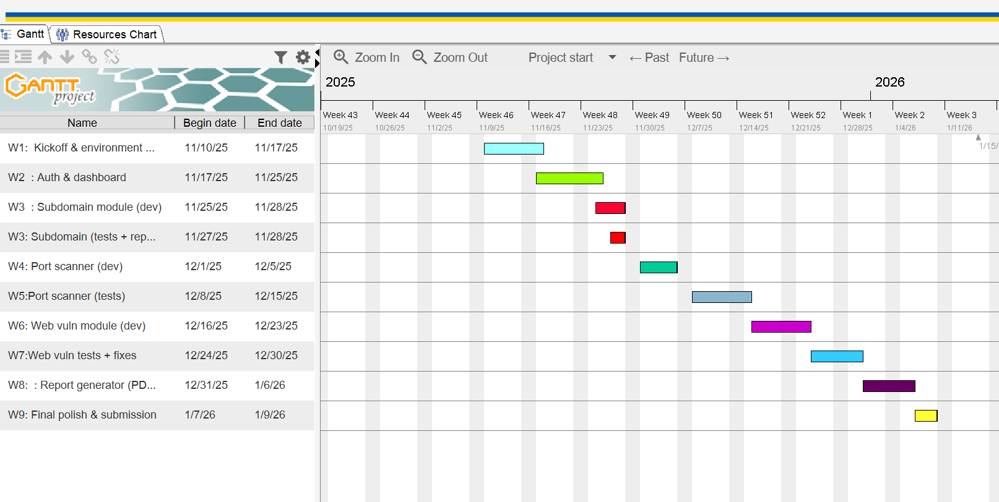

References
Basnet, S. (2021) Cybersecurity Challenges in Nepal. Kathmandu: Nepal Cyber Academy.
ENISA (2019) Penetration Testing Methodologies. European Union Agency for Cybersecurity.
Kubernetes, J. & Williams, R. (2020) Automating Security Testing in Modern Networks. London: CRC Press.
NTA (2023) Annual Cybersecurity Incident Report. Nepal Telecommunications Authority.
OWASP (2021) OWASP Top 10 Web Application Security Risks. Available at: https://owasp.org (Accessed: 20 November 2025).
Pressman, R. (2019) Software Engineering: A Practitioner’s Approach. 9th ed. New York: McGraw-Hill.
Scarfone, K. & Mell, P. (2008) Guide to Penetration Testing. National Institute of Standards and Technology (NIST).
Schwaber, K. & Sutherland, J. (2020) The Scrum Guide. Scrum.org.

